Campaign in Carlsbad, New Mexico, nets 82 souls!

Do I have some great news this time!

We just finished our WCM Campaign in Carlsbad, New Mexico! Are you sitting down? What I am about to tell you didn’t happen in a third-world country! It didn’t happen over a year-long effort either! It happened in less than a month! And in this country! Okay, here’s the great news: We saw 82 people come to the Lord! Sixty-nine of them obeyed the Gospel in baptism in just 10 days! The other 14 came in the two-to-three-weeks prior to the Campaign as three couples of us arrived ON SITE ahead of time to set up our RV electrical hookups and make the maps, etc, FOR the Campaign! I mean, it was an EXPLOSION!

These computers are amazing. Aha … I can show you pictures along the way of the story here!

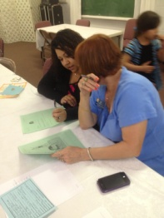
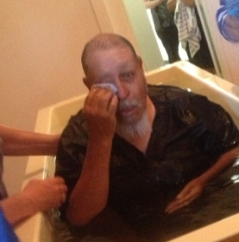
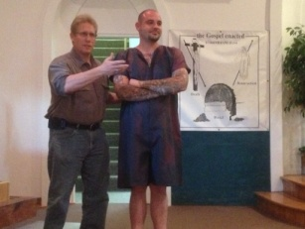
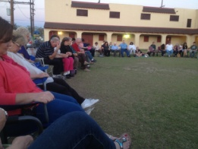
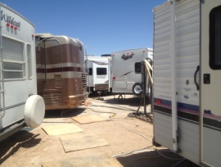
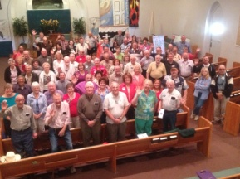
First, we trained local Christians in our We Care Approach. What a wonderful church is the Fox and Lake church! Also, our faithful Cadre came in to help train some “first timers.” As you see here at right, we saw 75 people arrive from all over the country, from 18 states, New York, Florida, South Dakota, Alabama, California … seemingly everywhere. We hooked up 15 RVs on the church property (above left). Then, we circled up and prayed, claiming the town for Christ (right), and “beautiful feet” hit the streets to start telling people THE GOSPEL OF CHRIST! And the Gospel did not come back void! People heard and came to Jesus! Our statistics showed that every fifth person we met in Carlsbad heard the Gospel of Christ! Yes, that’s one out of five! Then, of those who heard it, every fourth person OBEYED the Lord and became a Christian! And then … did the tears flow! HAPPY tears! This young man pictured on right above obeyed near the first of the Campaign and went out on the streets with us, learning how to share the Gospel with others … learning by DOING! Overjoyed should be his name! We circled up around the new Christians, welcoming them into God’s family, and then we took them into another room to continue to study (right), beginning the maturing and connecting.

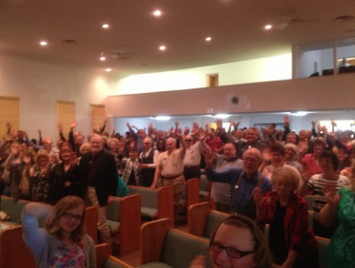
Three days during the Campaign we baptized into Christ nine people each day! NINE! We averaged SEVEN per day! Don’t let anyone tell you people are not interested! Oh, when there is movement among God’s people, there are those who even show up at the building! I mean, during the day people simply walked into the building and ASKED US for a Bible study! Incredible! ANNND … we saw no difference in the size of the audience, Sunday morning or Monday night! Or Tuesday night (right)! It was unbelievable!

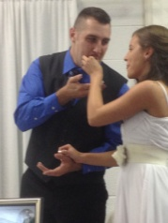
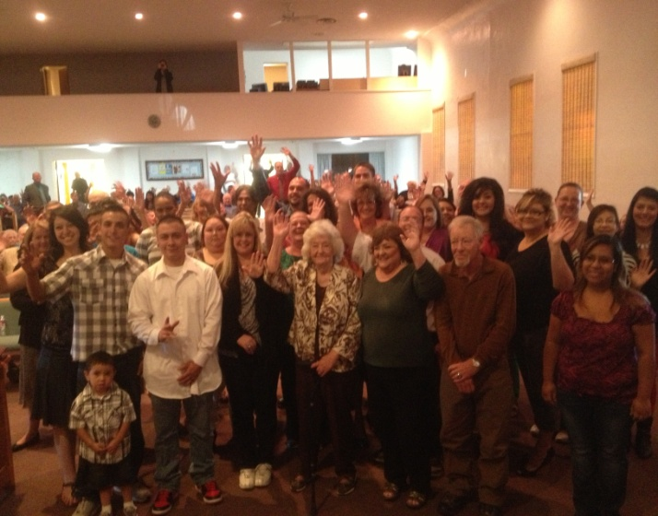
And now, here are some of your new brothers and sisters (below). Happy! Happy! Happy! And three congregations in town are benefiting from this growth. The Fox and Lake church was only around a hundred in attendance when we arrived. With 82 new souls, well, wow, other churches are helping to love them into the kingdom and teach them into maturity in Christ, and have grown as well!

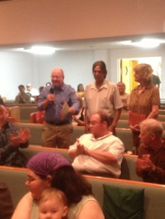
And … we had three weddings DURING the Campaign! Yes, we found couples living together in sin. They wanted salvation! So, naturally, we helped them get right both with the Lord and each other! It was just wonderful!

This new Christian couple (left), so says Jim Smith in our Cadre, is absolutely devouring God’s Word. He studied with them. He took them new lessons and left them. When he would go back the very next day, they had them all studied!

And since the Campaign ended, the church has put them to work, like, helping to teach children’s Bible classes. All three congregations in town are benefitting from this growth! Pray for these new Christians!

Well, I hope so much this thrills you with the power of God’s Word!

